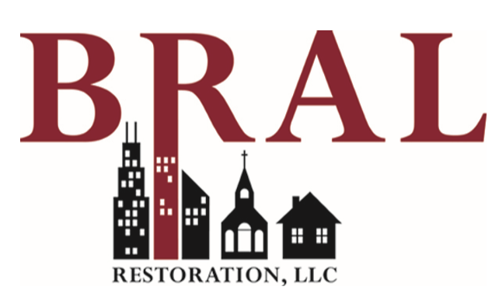

All FirstService Residential properties will receive a 5% discount of on all our services that we provide.

