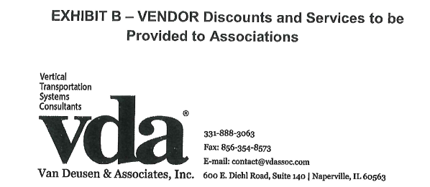

Additional benefits to FirstService Residential Illinois Properties

- Priority Request – Requests from FirstService Residential Illinois Properties will be executed upon at an expedited rate, where feasible.
- VDA has assigned a dedicated Consultant as a single point of contact for all FirstService Residential Illinois Properties.
- For all modernization projects the “Kick-off Meeting” will be provided at no cost. ($940.00 value)
- For all New Service Contract bidding projects, the “pre-bid meeting” will be provided at no cost. ($940.00)

